Operating Systems

Assignment Stimulation

Based

8TH Question

Student Name : RACHAPUDI SAI MARUTHI
Student ID : 11709752
Roll No : 50
Email Address : SAIMARUTHI1999@gmail.com
GitHub Link
Question :
Code :
#include<stdio.h>
struct process
{
int processID;
int burstTime;
int arrivalTime;
int priority;
int waitTime;
};
int total_time,burst_time=0;
int total=-1,i=-1;

struct process queue[100],result[100],swap;
int process_create()
{
int n;
printf("enter the number of process you want to enter:");
scanf("%d",&n);
return n;
}

void execute()
{
if(total>=0)
{
int wait,j;

if(burst_time!=0 && queue[0].burstTime!=0)
{
queue[0].burstTime--;
burst_time--;
queue[0].priority++;
queue[0].arrivalTime=total_time+1;
total_time++;

for(wait=1;wait<=total;wait++)
{
queue[wait].priority+=2;
queue[wait].waitTime=++queue[wait].waitTime;
}
}

if(queue[0].burstTime==0)
{
i++;
result[i]=queue[0];
for(wait=0;wait<total;wait++)
{
queue[wait]=queue[wait+1];
}
total--;
}

for(wait=0;wait<total;wait++)
{
for(j=0;j<total;j++)
{
if(queue[wait].priority<=queue[j].priority)
{
swap=queue[wait];
queue[wait]=queue[j];
queue[j]=swap;
}
}
}
if(queue[0].priority<=queue[1].priority && total>=1)
{
swap=queue[0];
for(wait=0;wait<total;wait++)
{
queue[wait]=queue[wait+1];
}
queue[total]=swap;
}
}
}

int main ()
{
int l,j,n=process_create(),count=0;
float averageWaitTime=0;
struct process pcreate[n];
for(l=0;l<n;l++)
{
pcreate[l].processID=l+1;
printf("\nEnter the arrival time of process[%d]: ",l+1);
scanf("%d",&pcreate[l].arrivalTime);
printf("\nEnter the burst time of process[%d]: ",l+1);
scanf("%d",&pcreate[l].burstTime);
pcreate[l].priority=0;
pcreate[l].waitTime=0;
burst_time=burst_time+pcreate[l].burstTime;
}
for(l=0;l<n;l++)
{
for(j=0;j<n;j++)
{
if(pcreate[l].arrivalTime<pcreate[j].arrivalTime)
{
swap=pcreate[l];
pcreate[l]=pcreate[j];
pcreate[j]=swap;
}
if(pcreate[l].arrivalTime==pcreate[j].arrivalTime)
{
if(pcreate[l].burstTime<=pcreate[j].burstTime)
{
swap=pcreate[l];
pcreate[l]=pcreate[j];
pcreate[j]=swap;
}
}
}
}
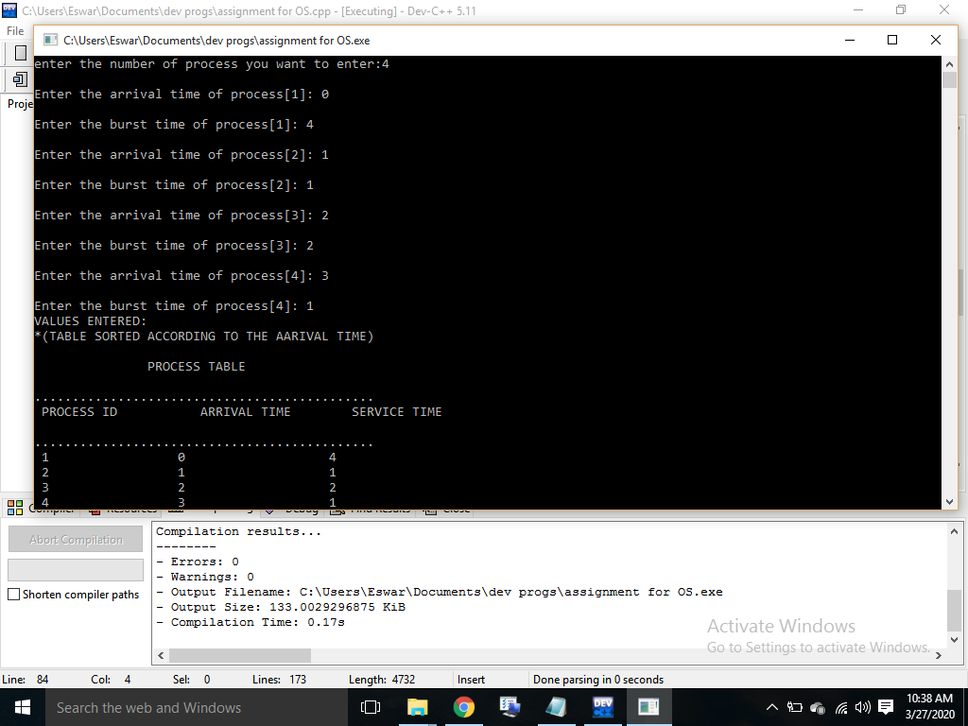
printf("VALUES ENTERED:\n*(TABLE SORTED ACCORDING TO THE AARIVAL TIME)\n\n");
printf(" PROCESS TABLE \n");
printf("\n.............................................\n");
printf(" PROCESS ID ARRIVAL TIME SERVICE TIME \n");
printf("\n.............................................\n");
for(l=0;l<n;l++)
{
printf(" %d %d %d\n",pcreate[l].processID,pcreate[l].arrivalTime,pcreate[l].burstTime );
}
total_time=pcreate[0].arrivalTime;
for(j=pcreate[0].arrivalTime;j<=pcreate[n-1].arrivalTime;j++)
{
for(l=0;l<n;l++)
{
if(pcreate[l].arrivalTime==j && count!=n)
{
total++;
queue[total]=pcreate[l];
count++;
}
if(count==n)
break;
}
execute();
total_time++;
while(burst_time!=0 && count==n)
{
execute();
total_time++;
}
if(count==n)
break;
}
printf("PROCESS IN ORDER OF THEIR COMPLETION:\n\n");
printf(" FINAL PROCESS EXECUTION TABLE \n");
printf("................................................................................\n");
printf(" PROCESS ID ARRIVAL TIME SERVICE TIME WAITING TIME\n");
printf("................................................................................\n");
for(l=0;l<n;l++)
{
for(j=0;j<n;j++)
{
if(result[l].processID==pcreate[j].processID)
{
printf(" %d %d %d %d\n",result[l].processID,pcreate[j].arrivalTime,pcreate[j].burstTime,result[l].waitTime);
break;
}
}
averageWaitTime+=(result[l].waitTime);
}
printf("AVERAGE WAITING TIME :%f\n",averageWaitTime/n);
}
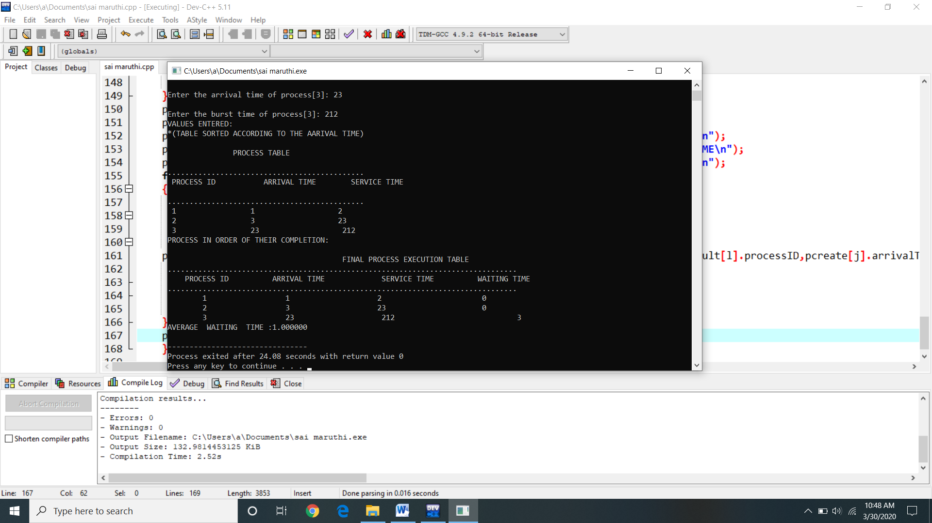
Test Cases : According to the question there is no more test cases because the arraival time and busrt time has already given by the user , that all are mentioned above .
There are four processes are given and for four there are four arraival times and four burst times are there and they all are given by the user if you want to add any another times , you have to mention the no processes at the top of the output I have mentioned that no of processes you want . Perhaps there is no need of these test cases
Description :
Arrival time : Time at which the process arrives in the ready queue. Completion Time: Time at which process completes its execution. Burst Time: Time required by a process for CPU execution.
Burst time : is the amount of time required by a process for executing on CPU. It is also called as execution time or running time. Burst time of a process can not be known in advance before executing the process. It can be known only after the process has executed.
Service time : The number of processes that are completed per time unit. ... Time blocked, waiting for I/O, is not part of the waiting time. service time. The amount of CPU time that a process will need before it either finishes or voluntarily exits the CPU, such as to wait for input / output.
Waiting time : = Turnaround time - Burst time
Response time is the time spent between the ready state and getting the CPU for the first time. But the waiting time is the total time taken by the process in the ready state. Let's take an example of a round-robin scheduling algorithm. The time quantum is 2 ms.
Turnaround time (TAT) : is the time interval from the time of submission of a process to the time of the completion of the process. It can also be considered as the sum of the time periods spent waiting to get into memory or ready queue, execution on CPU and executing input/output.
GitHub Repository :

